ADTA 5550.401: Deep Learning with Big Data

Biniam Abebe

Midterm Assessment

PART I: AI Deep Learning

Question 1.1: Overview of the history of artificial intelligence, including its sub-fields, machine learning, and deep learning.

#### Definition of Artificial Intelligence

#### Artificial intelligence is depicted as the need to automate human cognitive processes usually carried out by individuals. Artificial Intelligence, abbreviated as AI, encompasses different techniques and approaches used to develop systems with capacities to conduct tasks that would generally require human-like intelligence, including language understanding, learning, reasoning, or problem-solving. Artificial Intelligence (AI) can be found in different forms ranging from rule-based systems to complex models such as deep learning networks, which can continuously learn from data to improve their performance, a sign of adaptability and potentiality (Deep Learning with Python, p. 1).

#### Scope and Significance of AI's Historical Development

Several transformative milestones define the historical development of AI, identifying core dimensions which set its scope and significance in our minds as imaginations of what AI could become:

1. **1950s - Birth of AI**: At the beginning of artificial intelligence (AI) research, its pioneers were curious whether computers could think like human beings (Russell & Norvig, 2016). Many consider John McCarthy’s Dartmouth Conference in 1956 as marking the birth of artificial intelligence (AI). (Deep Learning with Python, p. 2)
2. **Symbolic AI (1950s-1980s)**: From the early days, AI research focused on symbolic AI that encoded intelligence in clear rules and logical expressions. This approach was good for explicit problems such as chess but poor at handling complex practical issues that necessitated more sophisticated AI research techniques (Deep Learning with Python, p.2-3)
3. **Machine Learning (1990s-Present)**: Switching to machine learning was a turning point for AI. Specifically, the invention of machine learning algorithms provided an alternative to hard-coding rules, which increased the scope of operation in areas ranging from medical science to finance. (Deep Learning with Python, p. 4-5; Hands-On Machine Learning, p. 15).
4. **Deep Learning (2010s-Present)**: Deep learning has revolutionized AI entirely thus far by enabling systems to learn hierarchical representations through several layers of artificial neural networks. As a result, this era saw improvements in natural language processing (NLP) and self-driving cars among others.

#### Reflection on AI's Journey and Current State

Although substantial advances over the years have enhanced various technology applications, as observed in autonomy medicine and personal transports, we are still very early in this AI journey. Consequently, however novel technologies emerge, like driverless cars or precision medicine, it might be helpful to maintain perspective. Nevertheless, instead of anticipating major strides, people need to realize that some tasks remain complex. For example, mastering human language in its totality or achieving true artificial general intelligence might require more decades of research Despite its impressive progress, AI is still in its early stages. Technology continues to improve, and new applications have been found, from autonomous vehicles to personalized medicine. However, it is crucial to manage expectations, as many complex tasks, such as general intelligence and truly understanding natural language, remain challenging and may take decades to achieve.

Moreover, the historical context underscores the importance of foundational and incremental developments for AI. A lot of the most important AI breakthroughs today are based on decades of work in things like neural networks and probabilistic models. Recognizing previous contributions as well as difficulties faced allows researchers today and tomorrow to navigate this field better.

Lastly, an understanding of its historical perspective will highlight various ethical and social issues attached to it. It is imperative to ensure that fairness, transparency, as well as accountability is strictly observed in relation to AI use within society lest we regret later when its adverse effects start manifesting themselves; thus, some insights gained in the past may be used to design principles for building beneficial artificial intelligence systems (Quote, Year).

References:

* François Chollet, *Deep Learning with Python* (Manning Publications Co., 2021).
* Aurélien Géron, *Hands-On Machine Learning with Scikit-Learn, Keras, and TensorFlow, 2nd Edition* (O'Reilly Media, 2019).

Question 1.2: Overview of deep learning, including (but not limited to) the relationship between deep learning and machine learning and artificial intelligence.

#### Definition of Deep Learning

Deep learning is a subset of machine learning characterized by using neural networks with many layers to learn features from data automatically. These features are arranged in a hierarchical order where the first layers capture simple aspects and later combine these to form more complex ones.

Context within AI and Machine Learning Deep learning is a part of artificial intelligence (AI), a broader discipline that aims to create systems capable of doing things that require human intelligence. Machine learning (ML) is focused on algorithms that improve their performance at specific tasks with experience in AI. Deep learning is on the frontier of ML, and neural networks are used to train them using huge datasets. They consist of interconnected nodes or neurons arranged in layers. Each connection carries a weight that changes during the training process. Basic structures are the input layer, hidden layers, and output layer.

Deep structures contain multiple hidden layers that enable them to recognize intricate patterns. In contrast to traditional ML-based models, DL doesn’t need human intervention when manually extracting features from raw input. Comparison with Traditional Machine Learning Approaches Traditional machine learning often relies on manually crafted features and simpler models, such as linear regression or decision trees. In contrast, deep learning models can automatically learn features from raw data through multiple layers of abstraction, making them particularly powerful for tasks involving unstructured data like images, audio, and text.

Summary of Deep Learning's Role in Advancing AI Capabilities

Deep learning has revolutionized the field of artificial intelligence (AI) by achieving significant breakthroughs through multilayered neural networks in various domains such as computer vision, natural language processing, and speech recognition. Unlike traditional machine learning approaches that require manual feature extraction, deep learning models identify trends between them automatically using raw data, facilitating the accomplishment of specific tasks. This automatic feature learning capability allows deep learning models to excel at handling complex, high-dimensional data, leading to near-human performance in many tasks.

In conclusion, deep learning has significantly advanced the capabilities of artificial intelligence, making it possible for us to solve complex problems that previously seemed insurmountable. As long as advances are being made in research this method will always remain central to shaping the future of AI and its application in various fields around us.

References:

* François Chollet, *Deep Learning with Python* (Manning Publications Co., 2021).
* Aurélien Géron, *Hands-On Machine Learning with Scikit-Learn, Keras, and TensorFlow, 2nd Edition* (O'Reilly Media, 2019).

Question 1.3: Why has Deep Learning been very popular in recent years?

Deep learning has made significant impacts in both academic research and industrial applications. Academically, it has opened new avenues for research in fields like computer vision, natural language processing, and reinforcement learning. In the industry, it has been adopted by tech giants for various applications, from improving search engines to creating advanced recommendation systems and autonomous vehicles (Deep Learning with Python, p. 1-2; Hands-On Machine Learning, p. 2).

The rise of deep learning has been facilitated by the increased computational power provided by GPUs (Graphics Processing Units), TPUs (Tensor Processing Units), and cloud computing resources. These technologies enable training large-scale neural networks, which was previously infeasible due to computational limitations and the availability of Big Data. The availability of massive datasets is another critical factor. Big data provides the vast amount of information required to train deep learning models, allowing them to learn from diverse and comprehensive datasets, leading to better generalization and performance (Deep Learning with Python, p. 21; Hands-On Machine Learning, p. 4).

For example, advancements in algorithms and architectures and innovations in algorithms and neural network architectures have also propelled deep learning. Techniques such as convolutional neural networks (CNNs), recurrent neural networks (RNNs), and transformers have enabled significant improvements in performance and capability across various tasks (Deep Learning with Python, p. 23; Hands-On Machine Learning, p. 4).

Popularity is heavily driven by Tech Giants' investment in AI Research. Major tech companies such as Google, Facebook, and Amazon have invested heavily in AI research and development, leading to rapid advancements and widespread adoption of deep learning technologies in their products and services.

In addition to the Tech Giants, wide-ranging Applications Across Various Sectors Deep learning applications span numerous industries, including healthcare for medical imaging, finance for fraud detection, and transportation for autonomous driving. These applications demonstrate the versatility and transformative potential of deep learning (Deep Learning with Python, p. 11-12).

The popularity of deep learning is driven by increased computational power, the availability of big data, advancements in algorithms and architectures, and the democratization of AI development through open-source tools and community collaboration (Deep Learning with Python, p. 466; Hands-On Machine Learning, p. 465).

In conclusion, Deep learning has significantly impacted various fields and holds immense potential for future advancements. Its ability to solve complex problems and drive innovation will continue to shape the future of technology and society (Deep Learning with Python, p. 467; Hands-On Machine Learning, p. 465).

References:

* François Chollet, *Deep Learning with Python* (Manning Publications Co., 2021).
* Aurélien Géron, *Hands-On Machine Learning with Scikit-Learn, Keras, and TensorFlow, 2nd Edition* (O'Reilly Media, 2019).

PART II: MLPs (Fully Connected Neural Networks) with Keras

Step 1 Result

A diagram of the neural network with all the layers, the neurons, and the feed-forwarding connections.  
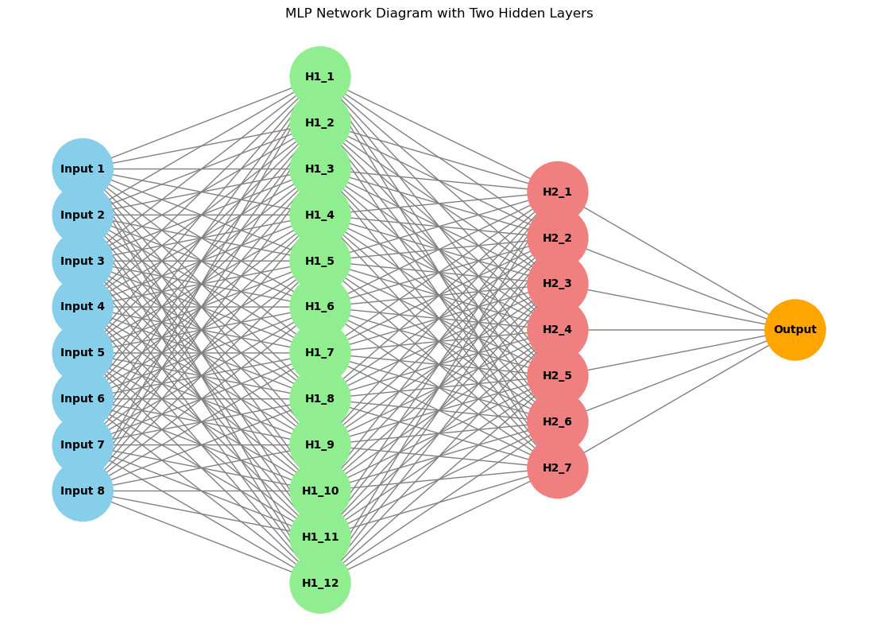

**Result and discussion**

**Observations**

1. **Training Accuracy**: The training accuracy improves steadily and stabilizes around 0.82.
2. **Training Loss**: The training loss decreases and stabilizes over time.

**Results from the Training Process**

* **Training Accuracy**: 76.32%
* **Training Loss**: 0.6480

**Compile Metrics**

* **Evaluation Accuracy**: 75.20%

**Comparison of Training and Evaluation Results**

* **Training Accuracy**: 76.32%
* **Evaluation Accuracy**: 75.20%

**Explanation of the Gap**

The small gap between training and evaluation accuracy (1.12%) indicates the model generalizes relatively well. The gap might be due to:

* **Overfitting**: Slightly higher training accuracy compared to evaluation accuracy suggests the model might have learned some noise from the training data.
* **Data Variability**: Differences in the training and validation splits during cross-validation can lead to minor variations in accuracy.

**Comparison with Iris Dataset**

* **Pima Dataset Accuracy**: ~75.20%
* **Iris Dataset Accuracy**: ~95%

**Reason for Gap Between Datasets**

* **Data Complexity**: The Pima dataset has more complex features and less clear class separation than the Iris dataset.
* **Class Distribution**: The Iris dataset has well-separated classes, making it easier for the model to achieve higher accuracy.

PART III: Redesign the MLP (30 Points)

Improving the model can involve various procedures, such as modifying the architecture, tuning hyperparameters, introducing regularization, or using more advanced techniques. Here are some stages and approaches you may use to improve your MLP model.

### Steps to Improve the Model

1. **Optimize the Architecture**:
   * Experiment with different numbers of neurons and layers.
   * Try different activation functions.
2. **Regularization Techniques**:
   * Add dropout layers to prevent overfitting.
   * Use L1 or L2 regularization.

The regularized model achieved the highest accuracy and lowest standard deviation, suggesting it generalizes better than the baseline and improved models. Here's a summary of the results:

* **Baseline Model Accuracy**: 75.25% (+/- 4.98%)
* **Improved Model Accuracy**: 73.82% (+/- 3.51%)
* **Regularized Model Accuracy**: 76.17% (+/- 2.36%)

**Analysis and Recommendations**

1. **Regularized Model Performance**:
   * The regularized model performed the best, indicating that dropout and L2 regularization helped prevent overfitting and improved generalization.
2. **Baseline Model**:
   * The baseline model had decent performance but with higher variability, suggesting it might slightly overfit the training data.
3. **Improved Model**:
   * The improved model with increased complexity did not perform as well, which might indicate that the additional complexity didn't provide a benefit or possibly led to overfitting.
   * Diagram for Improved Layer and Regularized Model

